Fadhlan Muhammad Razan

2440047463

**Question Set 1**

1. Genus and species have is-A relationship where Species is a Genus. Genus is a superclass to the species class where species is an extension of the genus class.
2. Species and specimen have has-A relationship where specimen referenced the species class in one of the classes attributes and methods

|  |
| --- |
| Specimen |
| -name: String  -cageNumber: int  -toa: Species |
| +setName(String: a): void  +setCage(int: c): void  +setTOA(Species: s): void  +getName(): String  +getCage(): int  +getTOA(): Species  +toString: String |

1. 1. One of the benefit that the progamming team gets from the relationship of the three objects is the reusability of certain methods that could be called/referenced in a different class. For example, rather than having to create a new method for setting genus in the species class, Since it is already available in the superclass the programmer would then only have to call the super() method of the genus class.

2. The other benefit of the three realtionships is the ease of access and readibility of the code. While this is not exclusive to the three objects, this is one of the main benefit of oop. Since all of the code are not written in a bulky 1 file, it is spreaded to different files so that if one of the code might cause an error, as a programmer it would be easy to find the code that cause the proble and fix it.

1. It would not cause an error since toString is an already built in method that is made when a class object is made. It would then return the class name along side the heap where the object is right now stored when called. A programmer could then override the method (without the usage of @override) to then override the toString() to return another string that would fit the programmers intention.

2. Overriding.

**Question set 2**

1. Encapsulation is the method for hiding certain variables/functions/methods so that it couldn’t be easily accessed by the regular user.
2. 1. Makes a class to only have access to certain variables.

2. Preventing a user from accessing a variable directly.

1. Accessor method:
   1. setName
   2. SetCage
   3. SetToa
   4. getName
   5. getCage
   6. getTOA
   7. toString
2. Instance variable:
   1. name
   2. cageNumber
   3. toa
3. 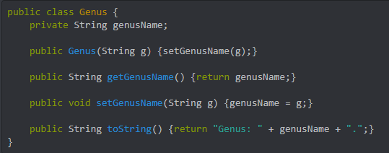
4. Advantage: Easier to make a specimen class since it already has the attributes and methods from the species class so as a programmer you only need to create new methods or override existing methods.

Disadvantage: By making it inherited from the species class, now both of this is classes would be dependant on one another. If the programmer wanted to change a method of the species class, it would affect all instances of the specimen class.

**Question Set 3**

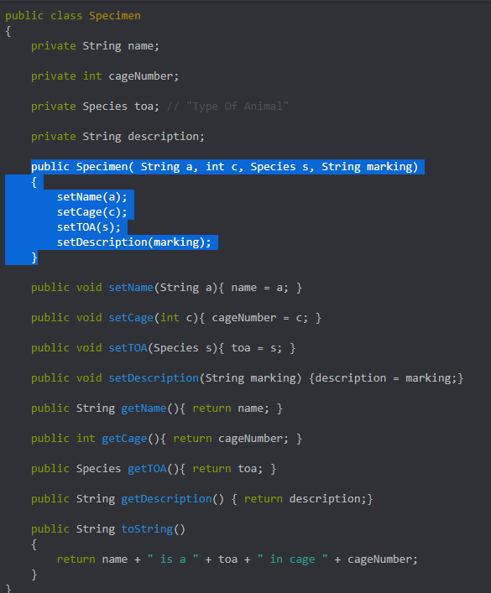

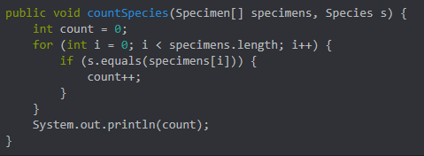

1. 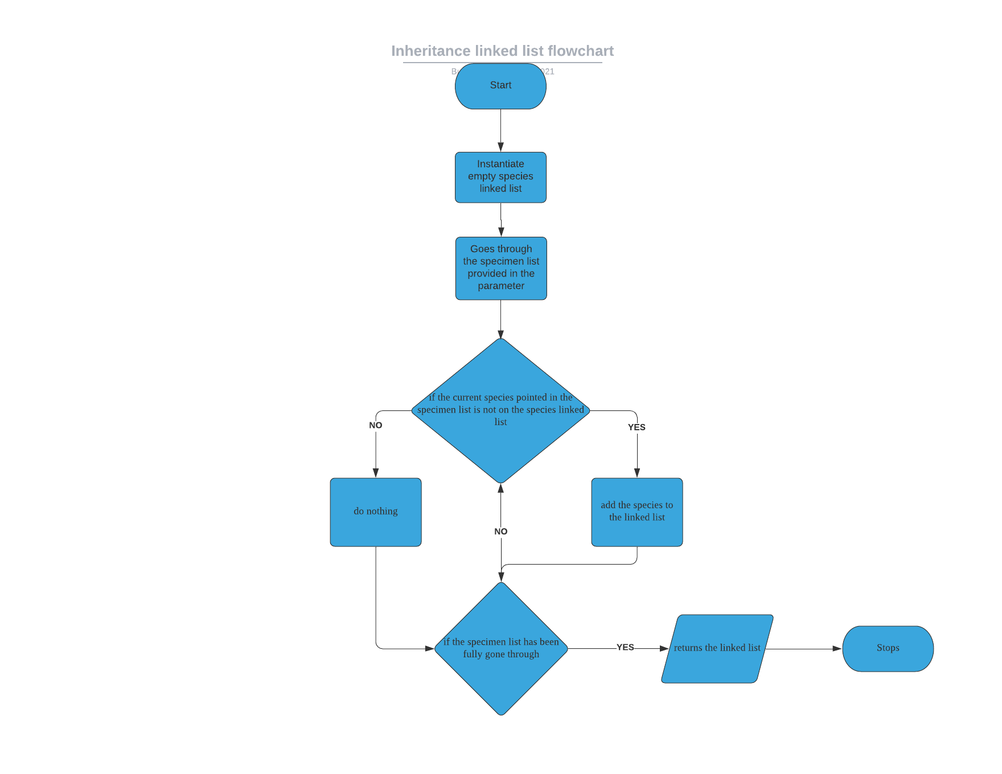

**Question Set 4**

1. ADT is a data type that is created by a progammer that is does not yet exist. It is used to create a new type of object that the progammer wants to create.
2. 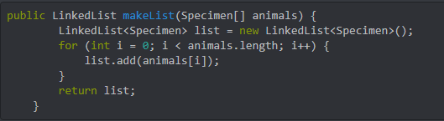
3. 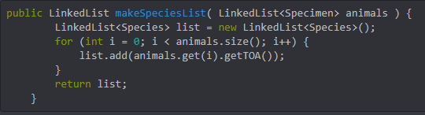
4. 